LIBRARY MANAGEMENT SYSTEM
A DBMS Capstone Project Report submitted in partial fulfillment of the requirements for the award of the degree of
BACHELOR OF TECHNOLOGY
in
ARTIFICIAL INTELLIGENCE AND MACHINE LEARNING

Submitted By
P. VENKAT – 25B11AI951
P. KIRAN – 25B11AI977
K. KARUNYA – 25B11AI741
K.SAI SASANK -25B11AI548
Under the esteemed guidance of
Mr. T.Srinivasulu M.Tech, (Ph.D.)
Assistant Professor



DEPARTMENT OF ARTIFICIAL INTELLIGENCE AND MACHINE LEARNING
ADITYA UNIVERSITY
(Formerly Aditya Engineering College (A))
Aditya Nagar, ADB Road, Surampalem, Andhra Pradesh, India
2026 – 2027

Aditya Nagar, ADB Road, Surampalem, Andhra Pradesh, India
DEPARTMENT OF ARTIFICIAL INTELLIGENCE AND MACHINE LEARNING
CERTIFICATE
This is to certify that the DBMS Capstone Project report entitled “LIBRARY MANAGEMENT SYSTEM” is being submitted by P. Venkat (Roll No. 25B11AI951), P. Kiran (Roll No. 25B11AI977) and K. Karunya (Roll No. 25B11AI741) ,K.Sai sasank (Roll NO. 25B11AI548), in partial fulfillment of the requirements for the award of the B.Tech. degree in Artificial Intelligence and Machine Learning. The work documented in this report was carried out as part of the Capstone Project for the course Database Management Systems (2501IT05) during the academic year 2026–2027, and records the database design, implementation, and documentation undertaken by the team.

Project Guide Head of the Department
Mr. T. Srinivasulu, M. Tech, (Ph.D.) Dr. K. Naga Bhargavi, M. Tech, Ph.D. Assistant professor Associate Professor & HOD

External Examiner

DECLARATION
We hereby declare that the DBMS Capstone Project entitled “LIBRARY MANAGEMENT SYSTEM” is a genuine work carried out by us. The database design, SQL implementation, queries and documentation presented in this report are our own work, completed under the guidance of Mr. T. Srinivasulu, Department of Artificial Intelligence and Machine Learning, Aditya University, Surampalem. We further declare that this work has not been submitted, in full or in part, for the award of any degree of this or any other educational institution.

Project Associates
P. Venkat (25B11AI951)
P. Kiran (25B11AI977)
K. Karunya (25B11AI748)
k.Sai sasank (25B11AI548)

Date: ____________
Place: Surampalem

ACKNOWLEDGEMENT
It is with immense pleasure that we express our indebted gratitude to our project guide Mr. T. Srinivasulu, Assistant Professor, Department of Artificial Intelligence and Machine Learning, who guided us throughout the capstone project. We are thankful for the constant encouragement and valuable suggestions received at every review stage.
We are grateful to Dr. K. Naga Bhargavi, Head of the Department, for inspiring us and for arranging the facilities and resources needed for this project.
We extend our sincere thanks to the Management, Dr. M. Sreenivasa Reddy, Deputy Pro-Chancellor, Dr. M. B. Srinivas, Vice-Chancellor, and Dr. A. Ramesh, Pro Vice-Chancellor (Engineering & Sciences), for providing an excellent academic environment.
Not to forget, we thank the Teaching and Non-Teaching Staff, our parents and our friends, who have directly or indirectly supported us in completing this project on time.

Project Associates
P. Venkat 25B11AI951
P. Kiran 25B11AI977
K. Karunya 25B11AI748
K.Sai Sasank 25B11AI548

ABSTRACT
A library handles a continuous flow of data about books, members and borrowing transactions, which is usually kept in registers or spreadsheets that lead to duplicate entries, slow searching and manual fine calculation. This capstone project presents the design and implementation of a Library Management System database in MySQL. The database stores the catalogue of books with their authors, publishers and categories, the registered members and librarians, the issue and return of books, and the fines charged for late returns. It consists of eight entities implemented as nine tables, normalized up to Third Normal Form, linked through primary and foreign keys and protected by NOT NULL, UNIQUE, CHECK and DEFAULT constraints. Sample data was loaded into every table and thirty-two SQL statements were prepared, covering DDL, DML, basic retrieval, joins, aggregate functions with GROUP BY and HAVING, nested and correlated subqueries, views, set operations, DCL and TCL. MySQL Workbench is used to run the queries, Graphviz to prepare the diagrams and GitHub to share the work. The resulting database keeps circulation records consistent, answers questions such as overdue books, unpaid fines and member history instantly, and forms a base for a future front-end application.

INDEX
Chapter | Title | Page No.
 | Certificate | 2
 | Declaration | 3
 | Acknowledgement | 4
 | Abstract | 5
 | List of Figures | 8
 | List of Tables | 8
1 | Introduction | 9
 | 1.1 Introduction to the Domain | 9
 | 1.2 Problem Statement | 9
 | 1.3 Motivation and Need for a Database | 9
 | 1.4 Objectives of the Project | 9
 | 1.5 Scope of the Project | 10
 | 1.6 Organization of the Report | 10
2 | System Study and Tools | 11
 | 2.1 Existing System and Its Limitations | 11
 | 2.2 Proposed Database System | 11
 | 2.3 Tools and Technologies Used | 11
 | 2.4 Software and Hardware Requirements | 11
3 | Database Design (Review – I) | 12
 | 3.1 Identified Entities | 12
 | 3.2 Entity Attributes and Attribute Types | 12
 | 3.3 ER Diagram | 13
 | 3.4 Relationships and Cardinality | 14
 | 3.5 Relational Database Schema | 15
 | 3.6 Primary Keys and Foreign Keys | 16
 | 3.7 Normalization up to 3NF | 17
4 | Database Implementation (Review – II) | 18
 | 4.1 Database and Table Creation – DDL | 18
 | 4.2 Sample Data Insertion – DML | 20
 | 4.3 Constraints and Data Integrity | 21
 | 4.4 Data Validation Rules | 22
5 | SQL Operations and Queries | 23
 | 5.1 DQL – Basic Retrieval Queries | 23
 | 5.2 Join Operations | 23
 | 5.3 Aggregate Functions, GROUP BY and HAVING | 24
 | 5.4 Nested and Correlated Subqueries | 24
 | 5.5 Views and Relational Set Operations | 24
 | 5.6 DCL and TCL Operations | 25
6 | Modules and Functionalities | 26
7 | Results – Sample Outputs and Screenshots | 27
8 | Testing and Data Validation | 29
9 | GitHub Repository and Team Contribution | 30
10 | Conclusion and Future Enhancements | 31
 | References | 18
 | Appendix A – Complete SQL Script | 33

LIST OF FIGURES
Figure No. | Title of the Figure | Page No.
Fig. 3.1 | ER Diagram of the Library Management System | 14
Fig. 3.2 | Relational Schema Diagram | 16
Fig. 4.1 | Successful Creation of Tables | 19
Fig. 4.2 | Sample Data Inserted into the Tables | 21
Fig. 4.3 | Referential Integrity Enforced by the Database | 22
Fig. 7.1 | Issue History of Members (Inner Join Output) | 27
Fig. 7.2 | Members with More Than One Issue (GROUP BY and HAVING) | 27
Fig. 7.3 | Books Never Issued (Nested Subquery) | 27
Fig. 7.4 | Transaction Control with SAVEPOINT and ROLLBACK | 28

LIST OF TABLES
Table No. | Title of the Table | Page No.
2.1 | Tools and Technologies Used | 11
2.2 | Software and Hardware Requirements | 11
3.1 | Entities Identified for the Selected Domain | 12
3.2 | Attributes of Each Entity | 12
3.3 | Relationships and Cardinality | 14
3.4 | Relational Database Schema | 15
3.5 | Primary Key and Foreign Key Definitions | 16
3.6 | Normalization Steps | 17
4.1 | Sample Data Summary | 20
4.2 | Constraints and Data Integrity Rules | 21
5.1 | Basic Retrieval Queries | 23
5.2 | Join Operations | 23
5.3 | Aggregate, GROUP BY and HAVING Queries | 24
5.4 | Subqueries | 24
5.5 | Views and Set Operations | 24
5.6 | DCL and TCL Operations | 25
6.1 | Modules and Their Functionalities | 26
8.1 | Test Cases and Results | 29
9.1 | Team Responsibilities | 30
9.2 | Review-wise Progress Record | 30

CHAPTER 1: INTRODUCTION

1.1 Introduction to the Domain
A library is an institution that collects, organises and lends books and other reading material to its members. A college or public library may hold thousands of titles across subjects such as computer science, mathematics, physics, literature and history, and may serve hundreds of students, faculty and readers every day.
On a typical day the library handles four kinds of information. The first is the catalogue: the title, ISBN, price, number of copies, authors, publisher and category of every book. The second is the membership: the name, contact details, joining date and status of every member. The third is circulation: which book was issued to which member, by which librarian, on what date, when it is due and when it was returned. The fourth is the fine charged when a book is returned after its due date.
Every borrowing links a member, a book and a librarian, and the same data is searched repeatedly: whether a book is available, which books are overdue, which members have unpaid fines and which titles are most popular. These interlinked and frequently queried records make the library a natural domain for a relational database.

1.2 Problem Statement
At present many small and medium libraries record books, members and issue details in paper registers or spreadsheets. The same member or book detail is typed again for every transaction, so the data becomes redundant and inconsistent: a changed phone number or book price may be updated in one place and missed in another. Searching for an overdue book or a member's history means scanning many pages, there is nothing to stop a book being issued to a member who does not exist, and fines are worked out by hand.
The proposed Library Management System stores each fact once in a separate table and connects the tables through primary and foreign keys. Constraints reject invalid and orphan records, and SQL queries retrieve availability, overdue lists, fines and member history in seconds.

1.3 Motivation and Need for a Database
A spreadsheet or file cannot enforce relationships between books, members and issues, cannot stop two users from corrupting the same record, and slows down as data grows. A DBMS removes redundancy through normalization, keeps data consistent through constraints and transactions, supports many users at the same time, controls who may read or change data through privileges, and answers complex questions through SQL. These abilities are exactly what a library needs to keep its catalogue, members and circulation records accurate.

1.4 Objectives of the Project
The project has the following objectives:
- To design a normalized relational database for the library domain with eight entities, normalized up to Third Normal Form.
- To implement the database in MySQL with appropriate primary keys, foreign keys and integrity constraints (NOT NULL, UNIQUE, CHECK and DEFAULT).
- To record the issue and return of books and the fines for late returns so that availability and dues can be found instantly.
- To write and execute at least fifteen SQL queries covering DDL, DML, DQL, joins, aggregates, subqueries, views, set operations, DCL and TCL.
- To test the database with constraint and referential-integrity cases and to share the final script on GitHub.

1.5 Scope of the Project
The database covers the book catalogue (books, authors, publishers and categories), library members, librarians, the issue and return of books, and the fines charged for late returns. All data is stored in nine tables of a MySQL database named library_db.
The project does not cover online book reservation, payment of fines through a payment gateway, e-books or digital content, barcode or RFID scanning, or a graphical front-end. Queries are run directly from MySQL Workbench.

1.6 Organization of the Report
This report is organized into ten chapters. Chapter 2 presents the system study and the tools used. Chapter 3 covers the complete database design including the ER diagram, relational schema and normalization. Chapter 4 describes the database implementation with DDL and sample data. Chapter 5 presents the SQL operations and queries executed. Chapter 6 explains the modules and functionalities. Chapter 7 presents the results with sample outputs. Chapter 8 covers testing and data validation. Chapter 9 details the GitHub repository and the contribution of each team member. Chapter 10 concludes the report and outlines future enhancements.

CHAPTER 2: SYSTEM STUDY AND TOOLS

2.1 Existing System and Its Limitations
In the existing manual or spreadsheet-based system, book details, member details and issue records are kept in registers or separate files. The system has the following limitations.
Data redundancy and inconsistency: the same member or book details are repeated in many records and may differ between copies. Difficult retrieval: finding overdue books, unpaid fines or the history of one member requires manual searching. No integrity checks: a book can be issued to a member who is not registered, or the same ISBN can be entered twice. Manual fine calculation is slow and error-prone. There is no access control, so anyone with the file can change any record, and no backup or recovery if the file is lost.

2.2 Proposed Database System
The proposed system is a relational database designed in Third Normal Form and implemented in MySQL. Books, authors, publishers, categories, members, librarians, issues and fines are stored in separate, related tables.
Its advantages over the existing system are: minimal redundancy because every fact is stored once; consistency through primary key, foreign key, UNIQUE, CHECK and NOT NULL constraints; fast retrieval of any information through SQL joins, aggregates and subqueries; secure access through GRANT and REVOKE; and safe updates through transactions that can be committed or rolled back.

2.3 Tools and Technologies Used
Table 2.1: Tools and Technologies Used
Category | Tool / Technology Used | Version / Remarks
Database Server | MySQL Community Server | 8.0 (8.0.31 or later for INTERSECT / EXCEPT)
Query / Admin Tool | MySQL Workbench | 8.0 – used to run SQL and view results
ER / Schema Diagrams | Graphviz (DOT) | ER and schema diagrams generated from DOT scripts; can be redrawn in draw.io
Front-end | None | Queries are run directly in MySQL Workbench
Version Control | Git and GitHub | Team repository for SQL script and report
Documentation | Microsoft Word | Project report in .docx format

2.4 Software and Hardware Requirements
Table 2.2: Software and Hardware Requirements
Requirement Type | Specification
Operating System | Windows 10 / 11 (64-bit)
Processor | Intel Core i3 or higher
RAM | 4 GB minimum (8 GB recommended)
Hard Disk | 1 GB free space for MySQL and project files
DBMS Software | MySQL Server 8.0 and MySQL Workbench 8.0
Other Software | Web browser, Git, Microsoft Word

CHAPTER 3: DATABASE DESIGN
(Deliverables of Review – I)

3.1 Identified Entities
Eight entities were identified for the library domain. They are listed in Table 3.1 with a one-line description of each.
Table 3.1: Entities Identified for the Selected Domain
S.No | Entity Name | Description
1 | Publisher | Company that publishes books; one publisher publishes many books.
2 | Category | Subject classification such as Computer Science or History.
3 | Author | Person who writes one or more books.
4 | Book | Title held by the library with its ISBN, price and number of copies.
5 | Member | Registered person who borrows books from the library.
6 | Librarian | Staff member who issues and receives books at the counter.
7 | Issue | Record of one book issued to one member, with issue, due and return dates.
8 | Fine | Amount charged for a book returned after its due date.

3.2 Entity Attributes and Attribute Types
Table 3.2 lists every attribute of every entity. The multi-valued attribute authors of Book is resolved into the table Book_Authors, and the derived attribute days_overdue of Issue (return date, or today's date, minus due date) is computed in queries and not stored.
Table 3.2: Attributes of Each Entity
Entity | Attribute | Data Type | Key (PK / FK / —) | Attribute Type
Publisher | publisher_id | INT | PK | Simple
Publisher | publisher_name | VARCHAR(100) | — | Simple
Publisher | city | VARCHAR(50) | — | Simple
Category | category_id | INT | PK | Simple
Category | category_name | VARCHAR(50) | — | Simple
Author | author_id | INT | PK | Simple
Author | author_name | VARCHAR(100) | — | Simple
Book | book_id | INT | PK | Simple
Book | title | VARCHAR(150) | — | Simple
Book | isbn | VARCHAR(20) | — | Simple
Book | price | DECIMAL(8,2) | — | Simple
Book | total_copies | INT | — | Simple
Book | available_copies | INT | — | Simple
Book | publisher_id | INT | FK | Simple
Book | category_id | INT | FK | Simple
Book | authors | — | — | Multi-valued
Member | member_id | INT | PK | Simple
Member | member_name | VARCHAR(100) | — | Simple
Member | email | VARCHAR(100) | — | Simple
Member | phone | VARCHAR(15) | — | Simple
Member | join_date | DATE | — | Simple
Member | status | VARCHAR(10) | — | Simple
Librarian | librarian_id | INT | PK | Simple
Librarian | librarian_name | VARCHAR(100) | — | Simple
Librarian | shift | VARCHAR(10) | — | Simple
Issue | issue_id | INT | PK | Simple
Issue | member_id | INT | FK | Simple
Issue | book_id | INT | FK | Simple
Issue | librarian_id | INT | FK | Simple
Issue | issue_date | DATE | — | Simple
Issue | due_date | DATE | — | Simple
Issue | return_date | DATE | — | Simple
Issue | days_overdue | INT (computed) | — | Derived
Fine | fine_id | INT | PK | Simple
Fine | issue_id | INT | FK | Simple
Fine | fine_amount | DECIMAL(8,2) | — | Simple
Fine | paid_status | VARCHAR(10) | — | Simple

3.3 ER Diagram
Fig. 3.1 shows the ER diagram. Entities are drawn as rectangles, attributes as ellipses with primary key attributes underlined (the derived attribute is dashed), and relationships as named diamonds with the cardinality marked on each line.
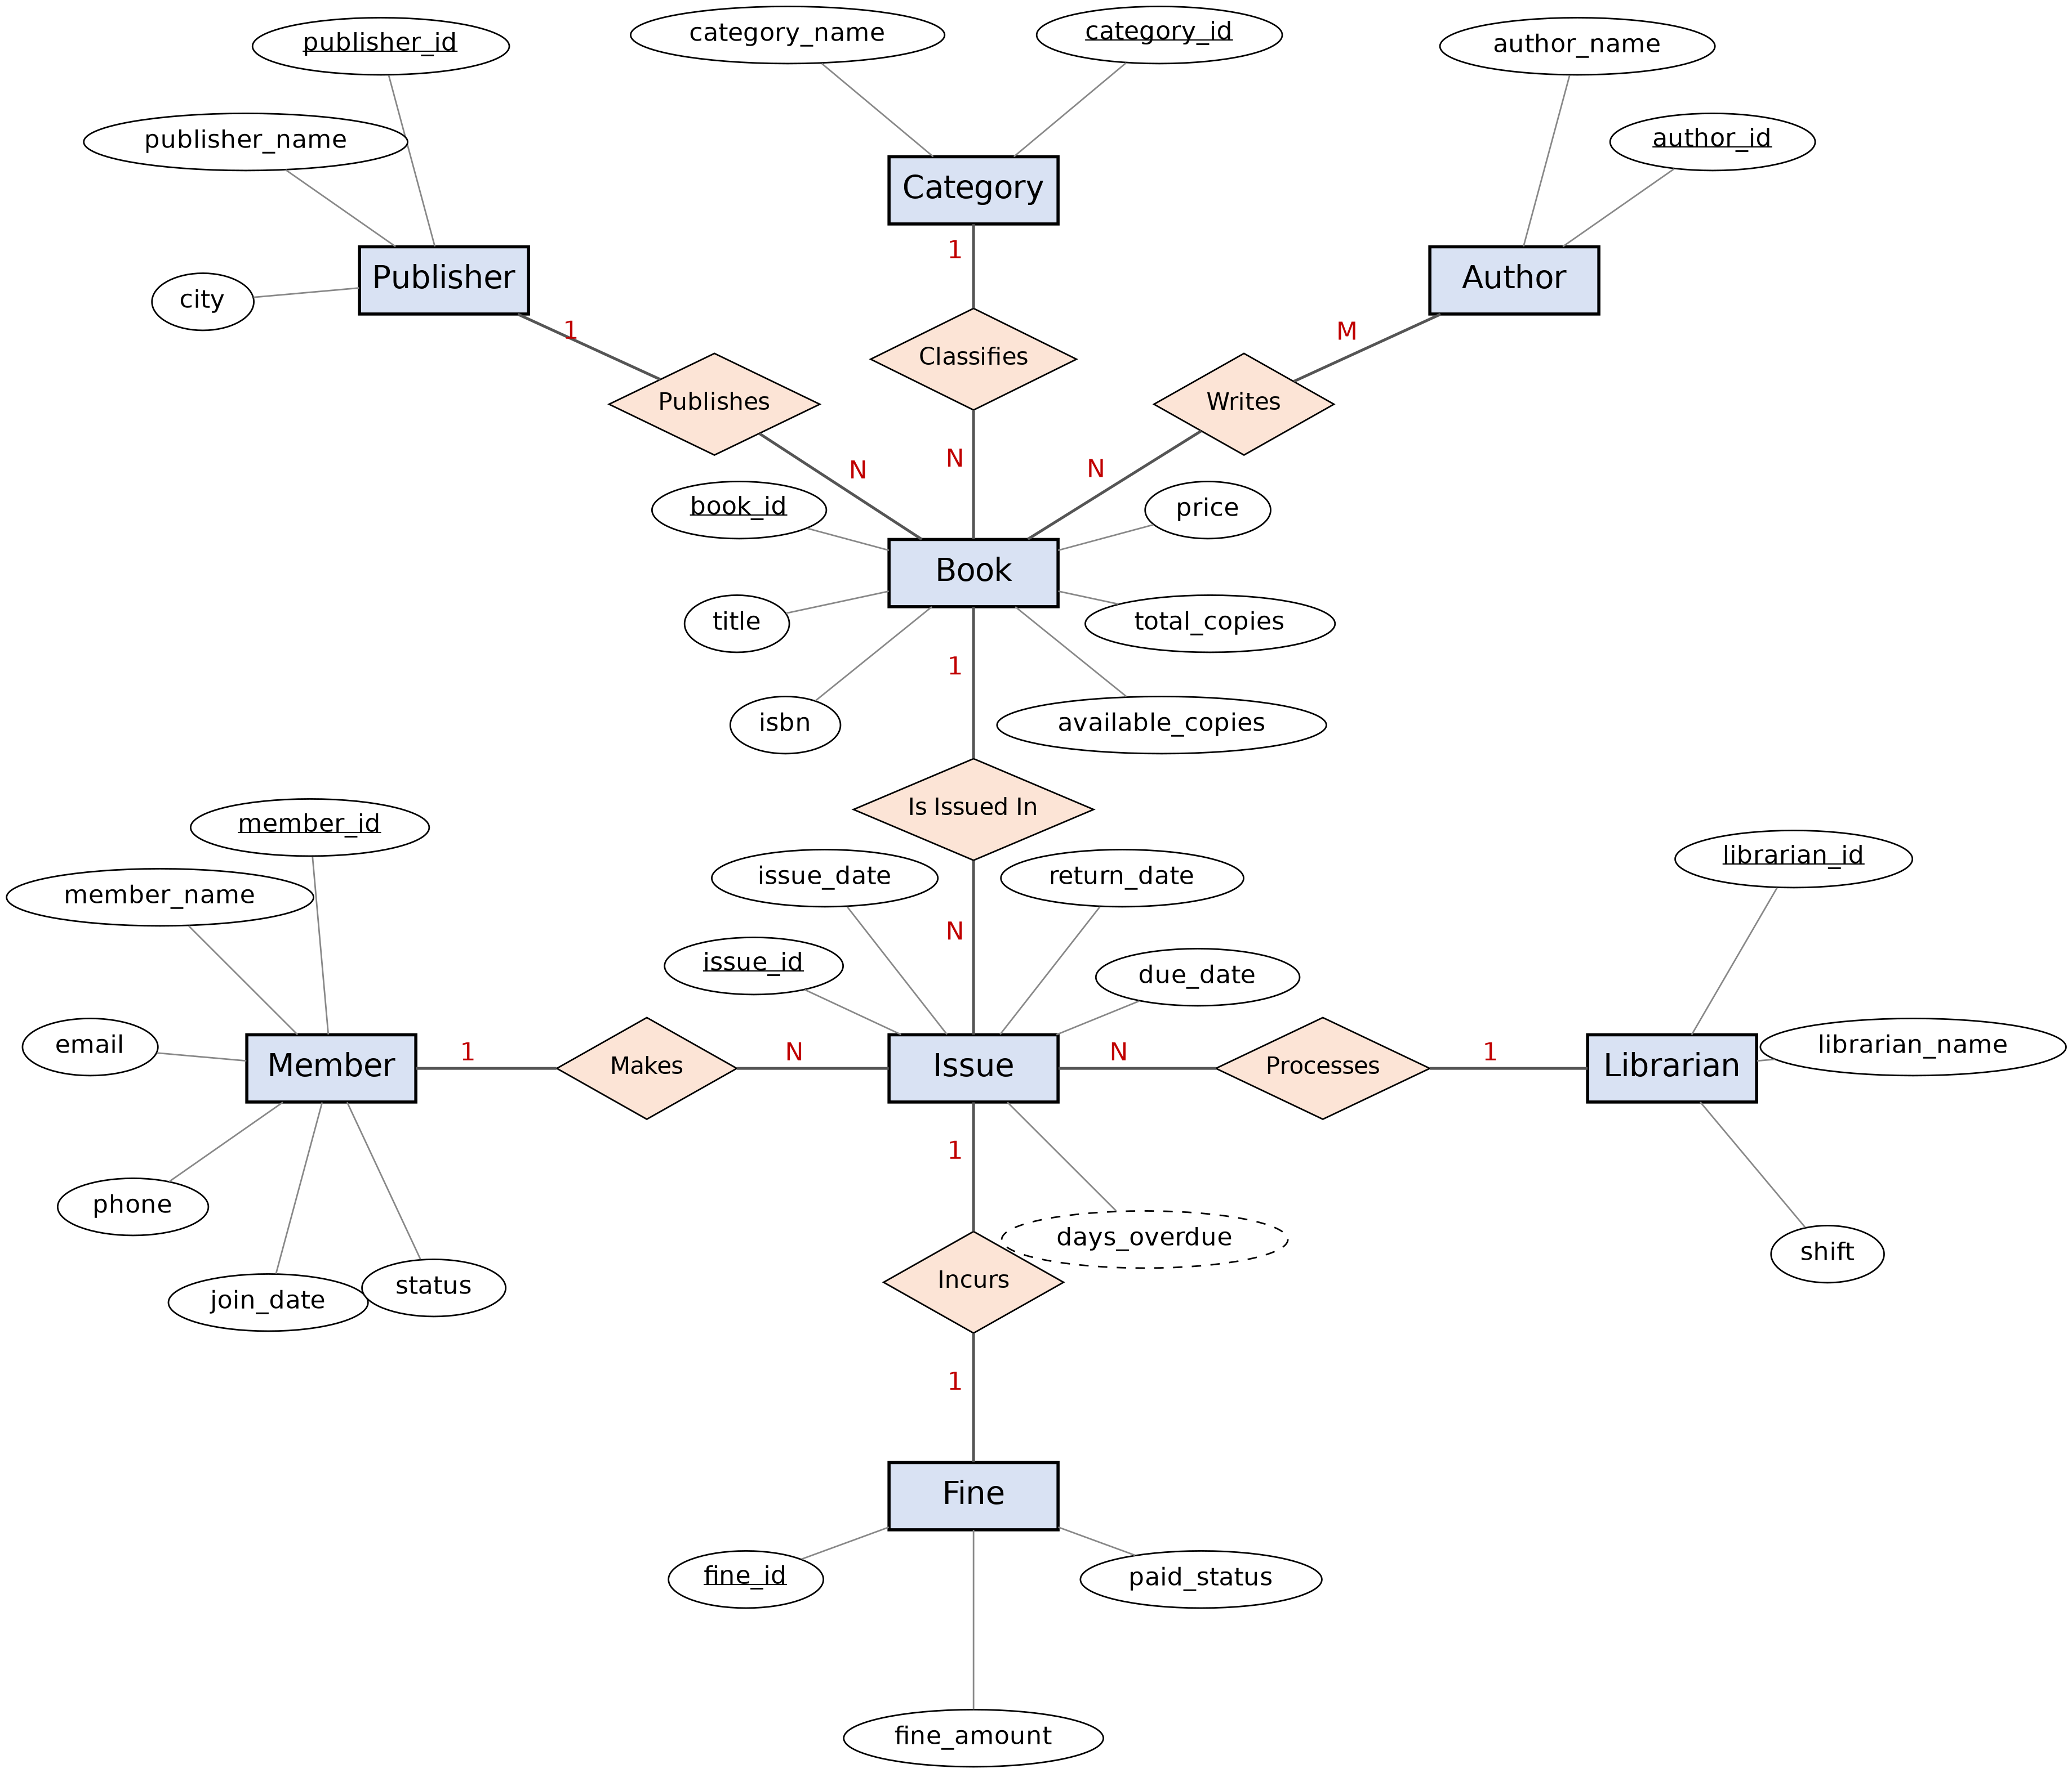

Fig. 3.1: ER Diagram of the Library Management System

3.4 Relationships and Cardinality
Table 3.3: Relationships and Cardinality
Entity 1 | Relationship | Entity 2 | Cardinality (1:1 / 1:N / M:N) | Participation
Publisher | Publishes | Book | 1:N | Publisher – partial; Book – total
Category | Classifies | Book | 1:N | Category – partial; Book – total
Author | Writes | Book | M:N | Author – total; Book – total
Member | Makes | Issue | 1:N | Member – partial; Issue – total
Book | Is Issued In | Issue | 1:N | Book – partial; Issue – total
Librarian | Processes | Issue | 1:N | Librarian – partial; Issue – total
Issue | Incurs | Fine | 1:1 | Issue – partial; Fine – total

3.5 Relational Database Schema
The ER diagram was converted into nine relational tables. Each entity became a table, each 1:N relationship became a foreign key on the 'N' side, and the M:N relationship Writes became the table Book_Authors with a composite primary key. Table 3.4 lists every column with its data type and constraints.
Table 3.4: Relational Database Schema
Table Name | Column Name | Data Type | Key (PK / FK / —) | Constraints
publishers | publisher_id | INT | PK | AUTO_INCREMENT
publishers | publisher_name | VARCHAR(100) | — | NOT NULL
publishers | city | VARCHAR(50) | — | NULL allowed
categories | category_id | INT | PK | AUTO_INCREMENT
categories | category_name | VARCHAR(50) | — | NOT NULL, UNIQUE
authors | author_id | INT | PK | AUTO_INCREMENT
authors | author_name | VARCHAR(100) | — | NOT NULL
books | book_id | INT | PK | AUTO_INCREMENT
books | title | VARCHAR(150) | — | NOT NULL
books | isbn | VARCHAR(20) | — | NOT NULL, UNIQUE
books | price | DECIMAL(8,2) | — | NOT NULL, CHECK (price > 0)
books | total_copies | INT | — | NOT NULL, DEFAULT 1, CHECK (>= 0)
books | available_copies | INT | — | NOT NULL, DEFAULT 1, CHECK (0 to total_copies)
books | publisher_id | INT | FK | NOT NULL
books | category_id | INT | FK | NOT NULL
book_authors | book_id | INT | PK, FK | NOT NULL, ON DELETE CASCADE
book_authors | author_id | INT | PK, FK | NOT NULL
members | member_id | INT | PK | AUTO_INCREMENT
members | member_name | VARCHAR(100) | — | NOT NULL
members | email | VARCHAR(100) | — | NOT NULL, UNIQUE
members | phone | VARCHAR(15) | — | CHECK (length = 10)
members | join_date | DATE | — | NOT NULL
members | status | VARCHAR(10) | — | NOT NULL, DEFAULT 'Active', CHECK (Active / Inactive)
librarians | librarian_id | INT | PK | AUTO_INCREMENT
librarians | librarian_name | VARCHAR(100) | — | NOT NULL
librarians | shift | VARCHAR(10) | — | NOT NULL, CHECK (Morning / Evening)
issues | issue_id | INT | PK | AUTO_INCREMENT
issues | member_id | INT | FK | NOT NULL
issues | book_id | INT | FK | NOT NULL
issues | librarian_id | INT | FK | NOT NULL
issues | issue_date | DATE | — | NOT NULL
issues | due_date | DATE | — | NOT NULL, CHECK (due_date > issue_date)
issues | return_date | DATE | — | NULL until returned
fines | fine_id | INT | PK | AUTO_INCREMENT
fines | issue_id | INT | FK | NOT NULL, UNIQUE
fines | fine_amount | DECIMAL(8,2) | — | NOT NULL, CHECK (>= 0)
fines | paid_status | VARCHAR(10) | — | NOT NULL, DEFAULT 'Unpaid', CHECK (Paid / Unpaid)

Schema Diagram
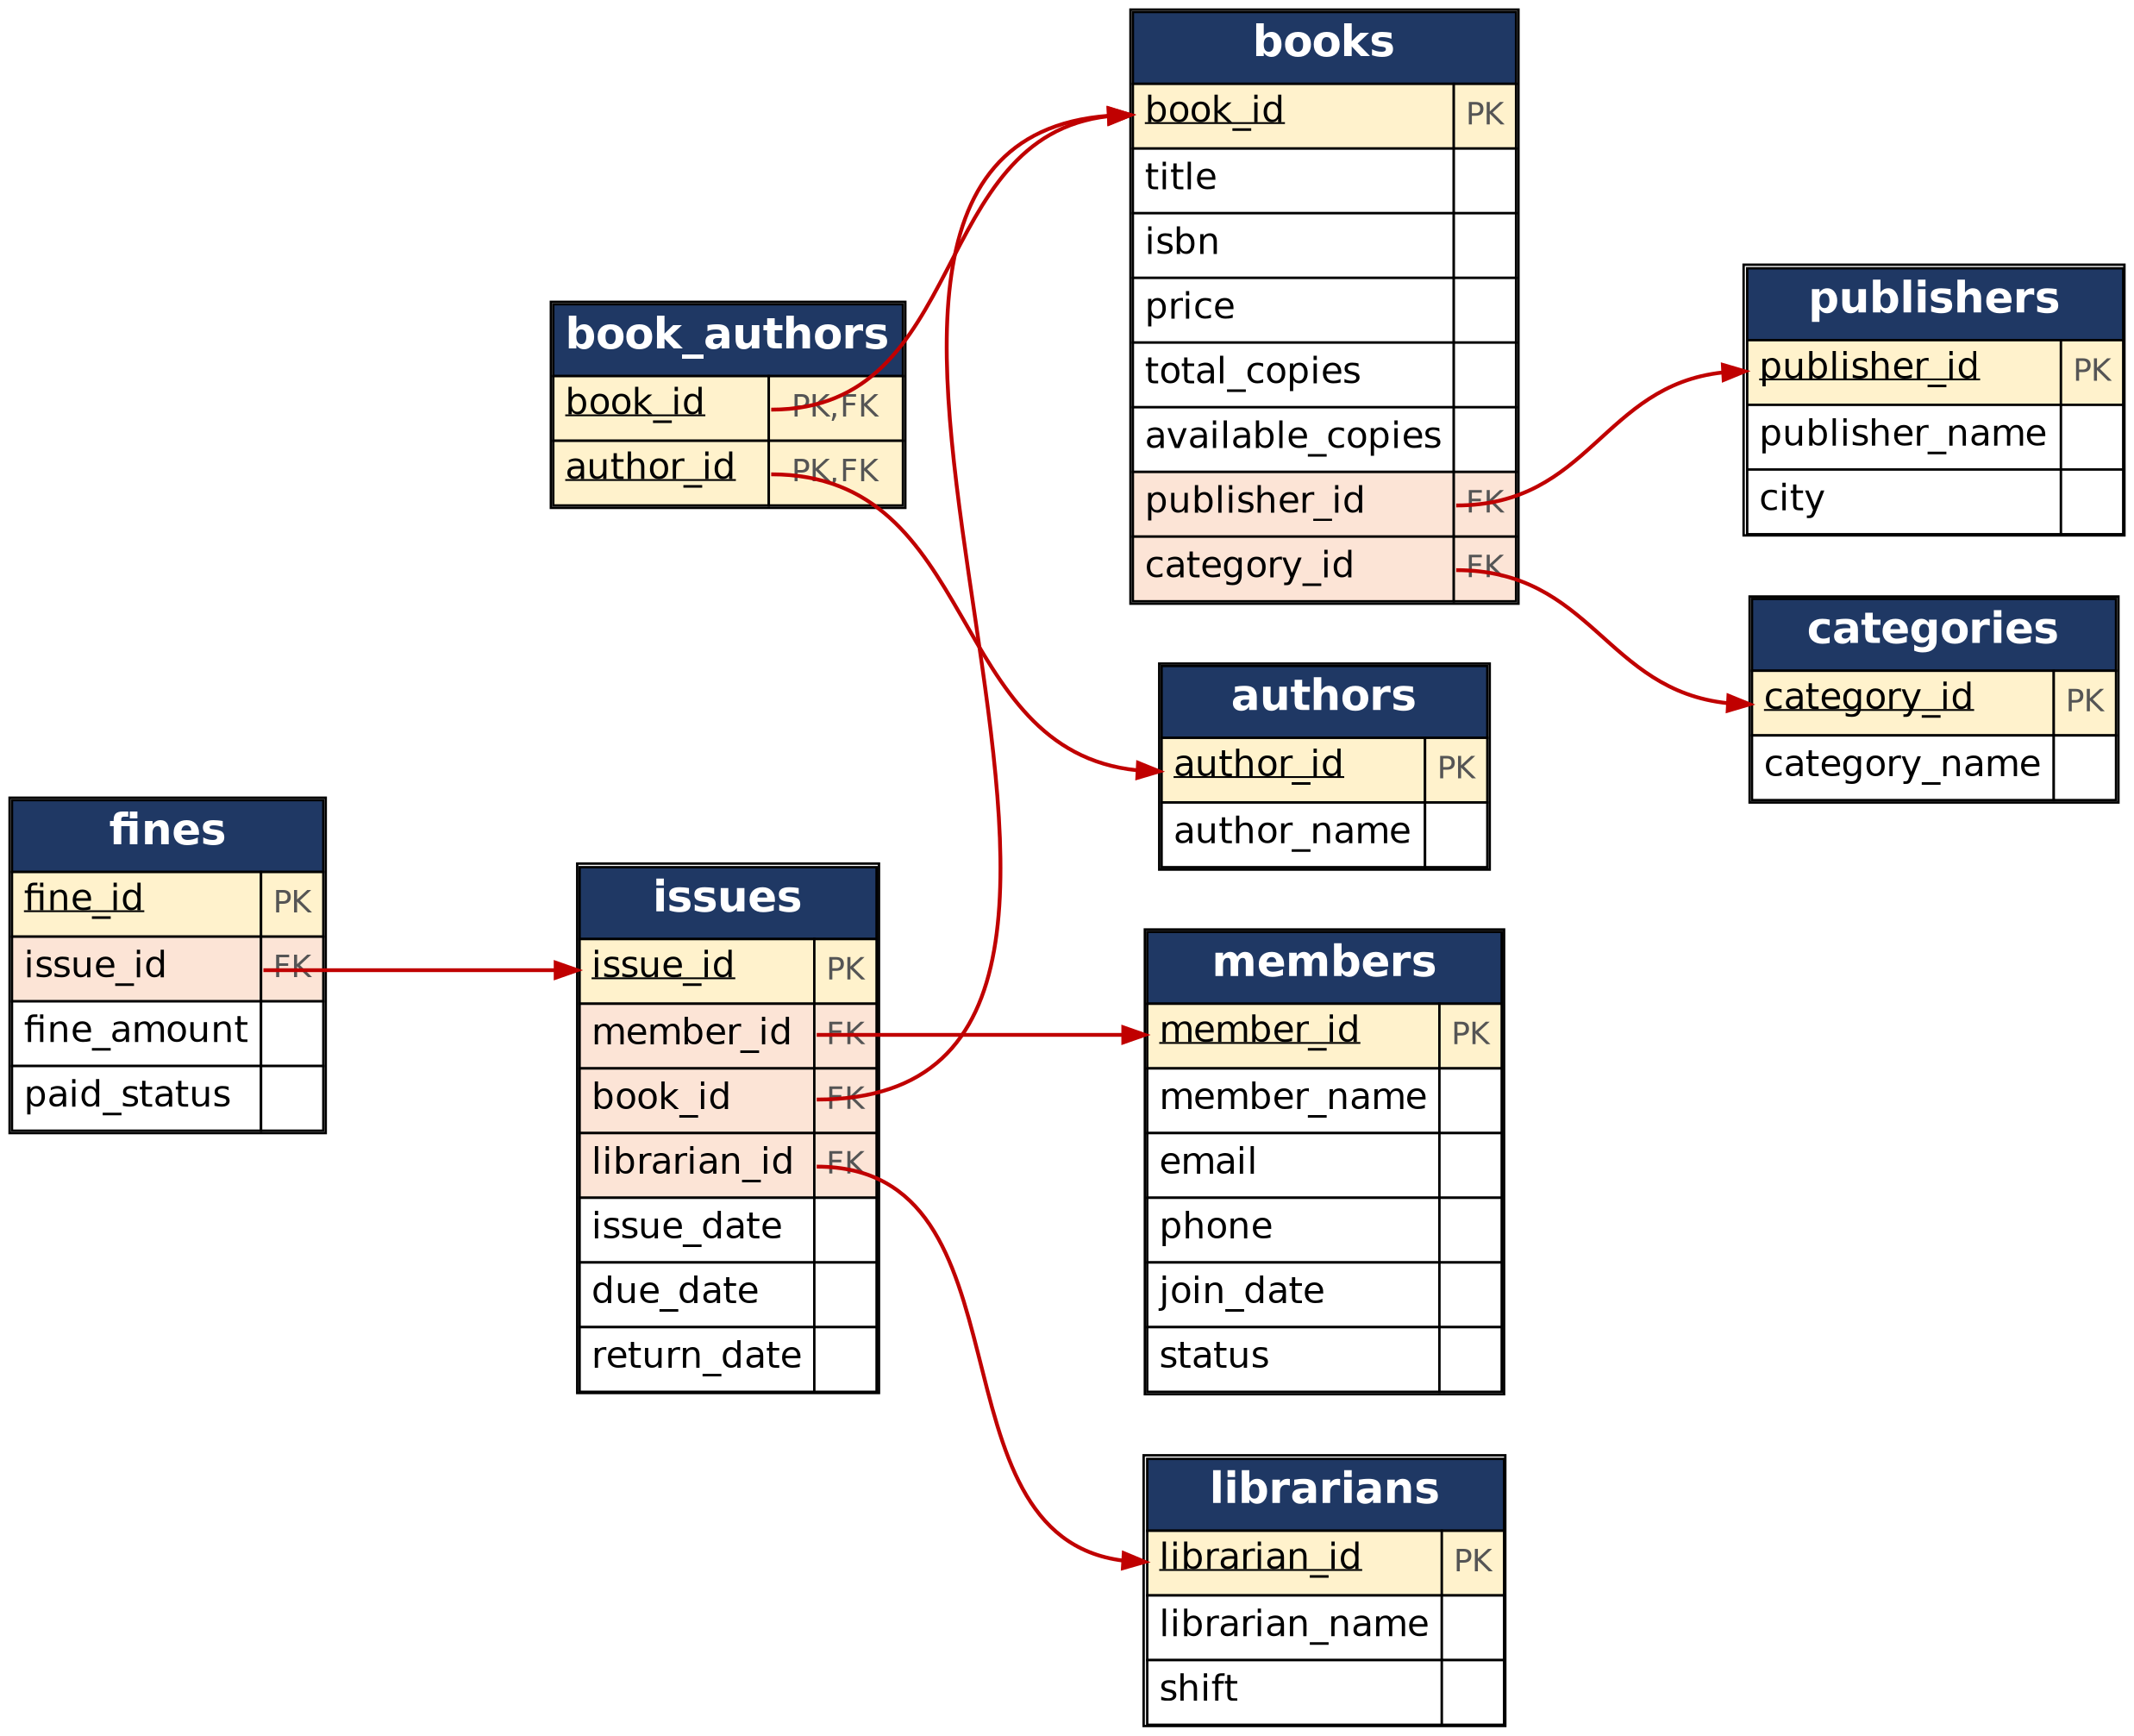

Fig. 3.2: Relational Schema Diagram

3.6 Primary Keys and Foreign Keys
Table 3.5: Primary Key and Foreign Key Definitions
Table | Primary Key | Foreign Key | References (Table.Column)
publishers | publisher_id | — | —
categories | category_id | — | —
authors | author_id | — | —
books | book_id | publisher_id, category_id | publishers.publisher_id, categories.category_id
book_authors | (book_id, author_id) | book_id, author_id | books.book_id, authors.author_id
members | member_id | — | —
librarians | librarian_id | — | —
issues | issue_id | member_id, book_id, librarian_id | members.member_id, books.book_id, librarians.librarian_id
fines | fine_id | issue_id | issues.issue_id

3.7 Normalization up to 3NF
Normalization was started from one unnormalized relation: LIBRARY(issue_id, member_id, member_name, email, phone, book_id, title, isbn, {author_name}, category_name, publisher_name, publisher_city, librarian_id, librarian_name, issue_date, due_date, return_date, fine_amount), where {author_name} is a repeating group.
The functional dependencies are: member_id → member_name, email, phone, join_date, status; book_id → title, isbn, price, total_copies, available_copies, publisher_id, category_id; publisher_id → publisher_name, city; category_id → category_name; librarian_id → librarian_name, shift; issue_id → member_id, book_id, librarian_id, issue_date, due_date, return_date; and issue_id → fine_amount, paid_status.
UNF → 1NF → 2NF → 3NF
Table 3.6: Normalization Steps
Normal Form | Condition Satisfied | Anomaly Removed | Resulting Tables
UNF | Single relation holding member, book, author list, publisher, librarian, issue and fine data. | Repeating group of authors; insert, update and delete anomalies. | LIBRARY (one wide relation)
1NF | Every attribute atomic; repeating author group removed by one row per book–author pair. | Multi-valued attribute authors. | Atomic issue rows and book_authors(book_id, author_id)
2NF | No partial dependency on part of a key: member, book, librarian and author details depend only on their own keys. | Member, book and librarian details repeated for every issue. | members, books, authors, librarians, book_authors, issues
3NF | No transitive dependency: publisher and category details depend on publisher_id and category_id, fine data on issue_id. | Publisher and category names repeated for every book. | publishers, categories, fines, plus the 2NF tables (9 tables)

CHAPTER 4: DATABASE IMPLEMENTATION
(Deliverables of Review – II)

4.1 Database and Table Creation – DDL
The database library_db is created with the following statements. They define all nine tables with their primary keys, foreign keys and NOT NULL, UNIQUE, CHECK and DEFAULT constraints, and one ALTER statement that adds a phone-number check.
CREATE DATABASE IF NOT EXISTS library_db;
USE library_db;

CREATE TABLE publishers (
publisher_id INT AUTO_INCREMENT PRIMARY KEY,
publisher_name VARCHAR(100) NOT NULL,
city VARCHAR(50)
);

CREATE TABLE categories (
category_id INT AUTO_INCREMENT PRIMARY KEY,
category_name VARCHAR(50) NOT NULL UNIQUE
);

CREATE TABLE authors (
author_id INT AUTO_INCREMENT PRIMARY KEY,
author_name VARCHAR(100) NOT NULL
);

CREATE TABLE books (
book_id INT AUTO_INCREMENT PRIMARY KEY,
title VARCHAR(150) NOT NULL,
isbn VARCHAR(20) NOT NULL UNIQUE,
price DECIMAL(8,2) NOT NULL,
total_copies INT NOT NULL DEFAULT 1,
available_copies INT NOT NULL DEFAULT 1,
publisher_id INT NOT NULL,
category_id INT NOT NULL,
CONSTRAINT chk_books_price CHECK (price > 0),
CONSTRAINT chk_books_copies CHECK (total_copies >= 0
AND available_copies >= 0 AND available_copies <= total_copies),
CONSTRAINT fk_books_publisher FOREIGN KEY (publisher_id)
REFERENCES publishers(publisher_id),
CONSTRAINT fk_books_category FOREIGN KEY (category_id)
REFERENCES categories(category_id)
);

CREATE TABLE book_authors (
book_id INT NOT NULL,
author_id INT NOT NULL,
PRIMARY KEY (book_id, author_id),
CONSTRAINT fk_ba_book FOREIGN KEY (book_id)
REFERENCES books(book_id) ON DELETE CASCADE,
CONSTRAINT fk_ba_author FOREIGN KEY (author_id)
REFERENCES authors(author_id)
);

CREATE TABLE members (
member_id INT AUTO_INCREMENT PRIMARY KEY,
member_name VARCHAR(100) NOT NULL,
email VARCHAR(100) NOT NULL UNIQUE,
phone VARCHAR(15),
join_date DATE NOT NULL,
status VARCHAR(10) NOT NULL DEFAULT 'Active',
CONSTRAINT chk_members_status CHECK (status IN ('Active','Inactive'))
);

CREATE TABLE librarians (
librarian_id INT AUTO_INCREMENT PRIMARY KEY,
librarian_name VARCHAR(100) NOT NULL,
shift VARCHAR(10) NOT NULL,
CONSTRAINT chk_librarians_shift CHECK (shift IN ('Morning','Evening'))
);

CREATE TABLE issues (
issue_id INT AUTO_INCREMENT PRIMARY KEY,
member_id INT NOT NULL,
book_id INT NOT NULL,
librarian_id INT NOT NULL,
issue_date DATE NOT NULL,
due_date DATE NOT NULL,
return_date DATE NULL,
CONSTRAINT chk_issues_dates CHECK (due_date > issue_date),
CONSTRAINT fk_issues_member FOREIGN KEY (member_id)
REFERENCES members(member_id),
CONSTRAINT fk_issues_book FOREIGN KEY (book_id)
REFERENCES books(book_id),
CONSTRAINT fk_issues_librarian FOREIGN KEY (librarian_id)
REFERENCES librarians(librarian_id)
);

CREATE TABLE fines (
fine_id INT AUTO_INCREMENT PRIMARY KEY,
issue_id INT NOT NULL UNIQUE,
fine_amount DECIMAL(8,2) NOT NULL,
paid_status VARCHAR(10) NOT NULL DEFAULT 'Unpaid',
CONSTRAINT chk_fines_amount CHECK (fine_amount >= 0),
CONSTRAINT chk_fines_status CHECK (paid_status IN ('Paid','Unpaid')),
CONSTRAINT fk_fines_issue FOREIGN KEY (issue_id)
REFERENCES issues(issue_id)
);

ALTER TABLE members
ADD CONSTRAINT chk_members_phone CHECK (CHAR_LENGTH(phone) = 10);

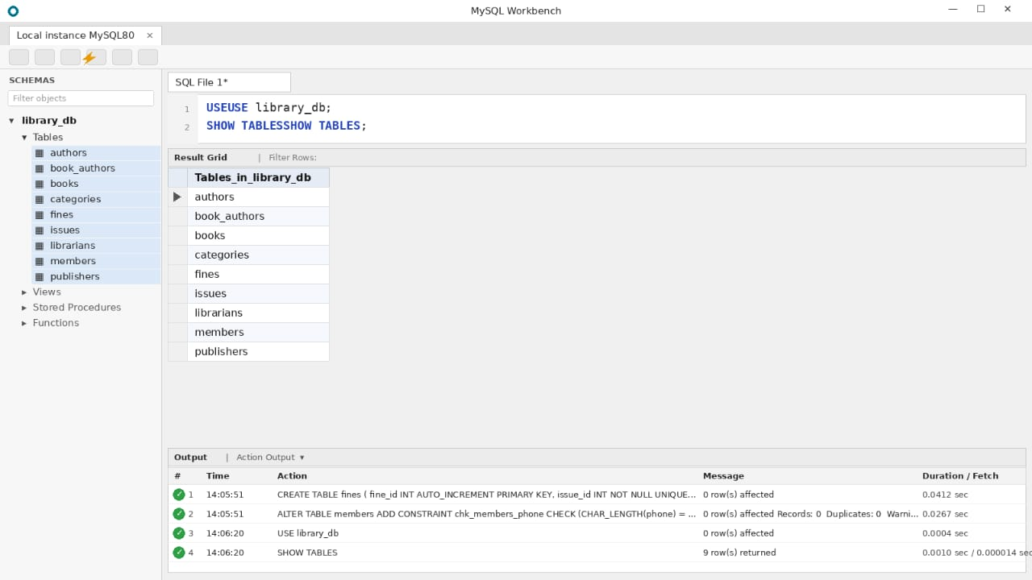

Fig. 4.1: Successful Creation of Tables

4.2 Sample Data Insertion – DML
Sample data was inserted into every table (Table 4.1). The script also shows UPDATE and DELETE examples.
Table 4.1: Sample Data Summary
S.No | Table Name | No. of Records Inserted | Screenshot Reference
1 | publishers | 5 | Fig. 4.2
2 | categories | 5 | Fig. 4.2
3 | authors | 12 | Fig. 4.2
4 | books | 10 | Fig. 4.2
5 | book_authors | 13 | Fig. 4.2
6 | members | 8 | Fig. 4.2
7 | librarians | 3 | Fig. 4.2
8 | issues | 12 | Fig. 4.2
9 | fines | 4 | Fig. 4.2

INSERT INTO publishers (publisher_name, city) VALUES
('McGraw-Hill Education','New York'),
('Pearson','London'),
('Oxford University Press','Oxford'),
('O''Reilly Media','Sebastopol'),
('Wiley India','New Delhi');

INSERT INTO categories (category_name) VALUES
('Computer Science'),('Mathematics'),('Literature'),('Physics'),('History');

INSERT INTO authors (author_name) VALUES
('Abraham Silberschatz'),('Henry F. Korth'),('S. Sudarshan'),
('Ramez Elmasri'),('Shamkant B. Navathe'),('Thomas H. Cormen'),
('R. K. Narayan'),('Erwin Kreyszig'),('H. C. Verma'),
('Bipin Chandra'),('Alan Beaulieu'),('Gilbert Strang');

INSERT INTO books (title, isbn, price, total_copies, available_copies,
publisher_id, category_id) VALUES
('Database System Concepts','978-1-0000-0001-1',899.00,5,3,1,1),
('Fundamentals of Database Systems','978-1-0000-0002-2',849.00,4,3,2,1),
('Introduction to Algorithms','978-1-0000-0003-3',1199.00,3,1,1,1),
('Advanced Engineering Mathematics','978-1-0000-0004-4',699.00,6,6,5,2),
('Malgudi Days','978-1-0000-0005-5',250.00,4,4,3,3),
('Concepts of Physics','978-1-0000-0006-6',550.00,3,2,5,4),
('A History of Modern India','978-1-0000-0007-7',420.00,2,2,3,5),
('Learning SQL','978-1-0000-0008-8',650.00,3,3,4,1),
('The Guide','978-1-0000-0009-9',300.00,3,3,3,3),
('Linear Algebra and Its Applications','978-1-0000-0010-0',480.00,2,2,2,2);

INSERT INTO book_authors (book_id, author_id) VALUES
(1,1),(1,2),(1,3),(2,4),(2,5),(3,6),(4,8),
(5,7),(6,9),(7,10),(8,11),(9,7),(10,12);

INSERT INTO members (member_name, email, phone, join_date) VALUES
('Anil Kumar','anil.kumar@example.com','9876543210','2026-01-10'),
('Sneha Rao','sneha.rao@example.com','9876543211','2026-01-15'),
('Rahul Verma','rahul.v@example.com','9876543212','2026-02-03'),
('Priya Sharma','priya.s@example.com','9876543213','2026-02-20'),
('Manoj Babu','manoj.b@example.com','9876543214','2025-11-05'),
('Divya Lakshmi','divya.l@example.com','9876543215','2026-03-12'),
('Suresh Naidu','suresh.n@example.com','9876543216','2025-12-18'),
('Harika Devi','harika.d@example.com','9876543217','2026-04-01');

INSERT INTO librarians (librarian_name, shift) VALUES
('Ravi Teja','Morning'),('Lakshmi Prasanna','Evening'),('Srinivas Rao','Morning');

INSERT INTO issues (member_id, book_id, librarian_id,
issue_date, due_date, return_date) VALUES
(1,1,1,'2026-08-01','2026-08-15','2026-08-14'),
(1,3,1,'2026-08-20','2026-09-03',NULL),
(2,2,2,'2026-08-05','2026-08-19','2026-08-25'),
(3,4,1,'2026-08-10','2026-08-24','2026-08-23'),
(4,3,3,'2026-09-01','2026-09-15',NULL),
(5,6,2,'2026-09-05','2026-09-19','2026-09-30'),
(2,1,2,'2026-09-10','2026-09-24',NULL),
(3,2,3,'2026-09-15','2026-09-29',NULL),
(6,4,1,'2026-09-18','2026-10-02','2026-10-01'),
(7,1,3,'2026-09-20','2026-10-04',NULL),
(7,6,1,'2026-09-22','2026-10-06',NULL),
(4,4,2,'2026-09-25','2026-10-09','2026-09-30');

INSERT INTO fines (issue_id, fine_amount, paid_status) VALUES
(3,12.00,'Paid'),(6,22.00,'Unpaid'),(2,62.00,'Unpaid'),(5,38.00,'Unpaid');

-- UPDATE and DELETE examples
UPDATE members SET phone = '9876500000' WHERE member_id = 2;
UPDATE books SET price = 920.00 WHERE book_id = 1;
INSERT INTO members (member_name, email, phone, join_date)
VALUES ('Test User','test.user@example.com','9000000000','2026-10-01');
DELETE FROM members WHERE email = 'test.user@example.com';

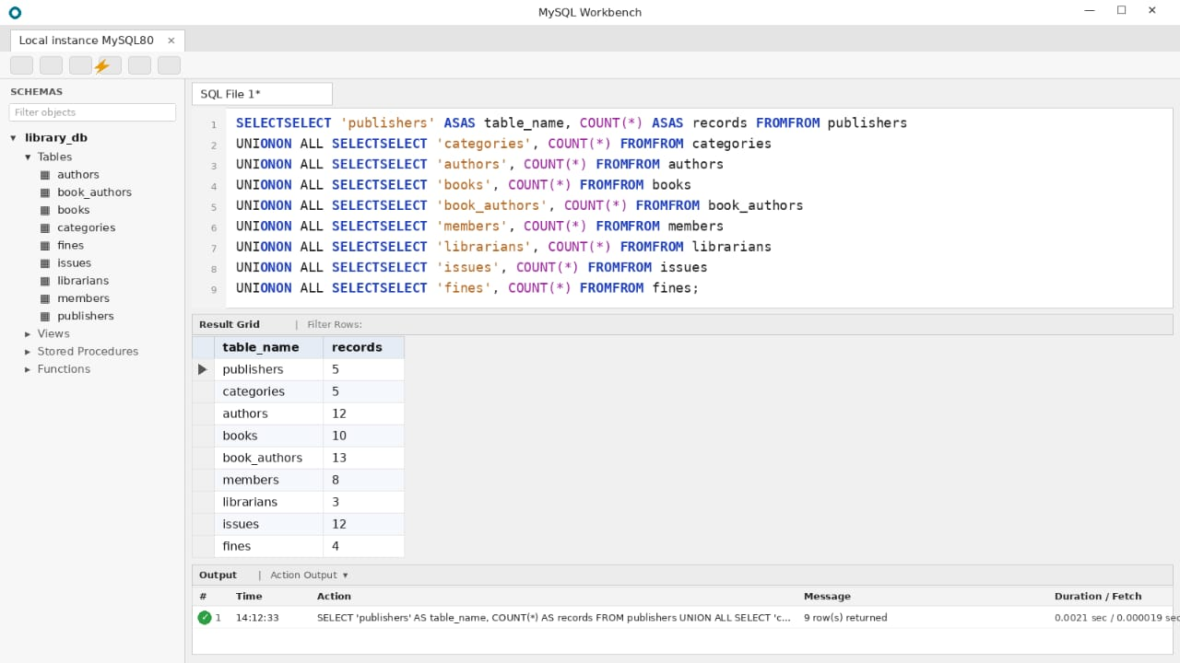

Fig. 4.2: Sample Data Inserted into the Tables

4.3 Constraints and Data Integrity
Table 4.2: Constraints and Data Integrity Rules
Constraint / Validation | Applied On (Table.Column) | Purpose | Evidence / Screenshot Ref.
PRIMARY KEY | All tables (e.g. books.book_id) | Uniquely identifies each row; no duplicate IDs | Sec. 4.1 DDL
FOREIGN KEY | books, issues, fines, book_authors | Prevents orphan records; links child to parent | Fig. 4.3
NOT NULL | books.title, members.member_name, issues.issue_date | Mandatory data must be supplied | Sec. 4.1 DDL
UNIQUE | books.isbn, members.email, categories.category_name, fines.issue_id | No two rows may share the value | Sec. 4.1 DDL
CHECK | books.price > 0; fines.fine_amount >= 0 | Rejects invalid numeric values | Sec. 4.1 DDL
CHECK | issues: due_date > issue_date | Due date must follow issue date | Sec. 4.1 DDL
CHECK | members.status; librarians.shift; fines.paid_status | Allows only listed values | Sec. 4.1 DDL
DEFAULT | members.status = Active; fines.paid_status = Unpaid | Supplies a value when none is given | Sec. 4.1 DDL

4.4 Data Validation Rules
Duplicate IDs are rejected by the PRIMARY KEY and UNIQUE constraints, invalid values (a negative price, a due date before the issue date or a status outside the allowed list) are rejected by CHECK constraints, and orphan records are prevented by FOREIGN KEY constraints.
For example, issuing a book to a member who does not exist fails:
INSERT INTO issues (member_id, book_id, librarian_id, issue_date, due_date) VALUES (999, 1, 1, '2026-10-01', '2026-10-15');
MySQL returns: ERROR 1452 (23000): Cannot add or update a child row: a foreign key constraint fails.
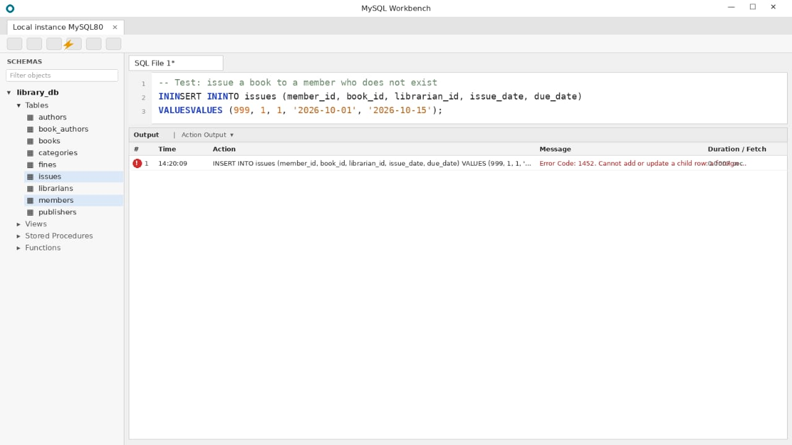

Fig. 4.3: Referential Integrity Enforced by the Database

CHAPTER 5: SQL OPERATIONS AND QUERIES
Thirty-two statements (Q1 to Q32) were prepared for the Library Management System. Each is given with its purpose and SQL statement; the output screenshots are in Chapter 7 and the complete script is in Appendix A.

5.1 DQL – Basic Retrieval Queries
Table 5.1: Basic Retrieval Queries
Q.No | Purpose of the Query | SQL Statement | Output Ref.
Q1 | Display all books in the catalogue | SELECT * FROM books; | Appendix A
Q2 | Books priced above Rs. 500, costliest first | SELECT title, price FROM books  WHERE price > 500 ORDER BY price DESC; | Appendix A
Q3 | Members who joined in 2026 | SELECT member_name, email FROM members  WHERE join_date >= '2026-01-01'; | Appendix A
Q4 | Books whose title contains 'Database' | SELECT book_id, title FROM books  WHERE title LIKE '%Database%'; | Appendix A
Q5 | Books issued but not yet returned | SELECT issue_id, member_id, book_id, due_date  FROM issues WHERE return_date IS NULL; | Appendix A

5.2 Join Operations
Natural, equi, inner, left outer, right outer and full outer joins are shown below. MySQL has no FULL OUTER JOIN keyword, so Q11 combines a LEFT JOIN and a RIGHT JOIN with UNION.
Table 5.2: Join Operations
Q.No | Type of Join | SQL Statement | Output Ref.
Q6 | Natural join | SELECT title, category_name  FROM books NATURAL JOIN categories; | Appendix A
Q7 | Equi join | SELECT b.title, p.publisher_name  FROM books b, publishers p  WHERE b.publisher_id = p.publisher_id; | Appendix A
Q8 | Inner join (3 tables) | SELECT m.member_name, b.title, i.issue_date  FROM issues i  INNER JOIN members m ON i.member_id = m.member_id  INNER JOIN books b ON i.book_id = b.book_id; | Fig. 7.1
Q9 | Left outer join | SELECT m.member_name, i.issue_id  FROM members m  LEFT JOIN issues i ON m.member_id = i.member_id; | Appendix A
Q10 | Right outer join | SELECT i.issue_id, b.title  FROM issues i  RIGHT JOIN books b ON i.book_id = b.book_id; | Appendix A
Q11 | Full outer join (LEFT UNION RIGHT) | SELECT b.title, i.issue_id  FROM books b LEFT JOIN issues i ON b.book_id = i.book_id  UNION  SELECT b.title, i.issue_id  FROM books b RIGHT JOIN issues i ON b.book_id = i.book_id; | Appendix A

5.3 Aggregate Functions, GROUP BY and HAVING
Table 5.3: Aggregate, GROUP BY and HAVING Queries
Q.No | Function Used | SQL Statement | Output Ref.
Q12 | COUNT | SELECT COUNT(*) AS total_titles FROM books; | Appendix A
Q13 | SUM, AVG | SELECT SUM(total_copies) AS copies, AVG(price) AS avg_price  FROM books; | Appendix A
Q14 | COUNT with GROUP BY | SELECT c.category_name, COUNT(*) AS titles  FROM books b JOIN categories c  ON b.category_id = c.category_id  GROUP BY c.category_name; | Appendix A
Q15 | COUNT, GROUP BY, HAVING | SELECT member_id, COUNT(*) AS books_issued  FROM issues GROUP BY member_id  HAVING COUNT(*) > 1; | Fig. 7.2
Q16 | MAX, MIN | SELECT MAX(price) AS costliest, MIN(price) AS cheapest  FROM books; | Appendix A

5.4 Nested and Correlated Subqueries
Table 5.4: Subqueries
Q.No | Type (Nested / Correlated) | SQL Statement | Output Ref.
Q17 | Nested (scalar subquery) | SELECT title, price FROM books  WHERE price > (SELECT AVG(price) FROM books); | Appendix A
Q18 | Nested (IN) | SELECT member_name FROM members  WHERE member_id IN (SELECT member_id FROM issues); | Appendix A
Q19 | Nested (NOT IN) | SELECT title FROM books  WHERE book_id NOT IN (SELECT book_id FROM issues); | Fig. 7.3
Q20 | Correlated | SELECT b.title, b.price FROM books b  WHERE b.price > (SELECT AVG(b2.price) FROM books b2  WHERE b2.category_id = b.category_id); | Appendix A
Q21 | Correlated (EXISTS) | SELECT m.member_name FROM members m  WHERE EXISTS (SELECT 1 FROM issues i  JOIN fines f ON f.issue_id = i.issue_id  WHERE i.member_id = m.member_id  AND f.paid_status = 'Unpaid'); | Appendix A

5.5 Views and Relational Set Operations
Q22 is an updatable view because it is a simple projection of one table; Q23 is non-updatable because it uses GROUP BY and an aggregate. UNION, INTERSECT and EXCEPT (the MySQL equivalent of MINUS) are shown in Q24 to Q26; INTERSECT and EXCEPT need MySQL 8.0.31 or later.
Table 5.5: Views and Set Operations
Q.No | View / Set Operation | SQL Statement | Output Ref.
Q22 | Updatable view (simple, single table) | CREATE VIEW available_books AS  SELECT book_id, title, available_copies  FROM books WHERE available_copies > 0; | Appendix A
Q23 | Non-updatable view (GROUP BY) | CREATE VIEW member_issue_count AS  SELECT m.member_id, m.member_name,  COUNT(i.issue_id) AS total_issues  FROM members m LEFT JOIN issues i  ON m.member_id = i.member_id  GROUP BY m.member_id, m.member_name; | Appendix A
Q24 | UNION | SELECT member_name AS person_name FROM members  UNION  SELECT librarian_name FROM librarians; | Appendix A
Q25 | INTERSECT | SELECT issue_id FROM issues  INTERSECT  SELECT issue_id FROM fines; | Appendix A
Q26 | EXCEPT (MINUS) | SELECT book_id FROM books  EXCEPT  SELECT book_id FROM issues; | Appendix A

5.6 DCL and TCL Operations
Q27 and Q28 show DCL (GRANT and REVOKE). Q29 to Q32 show TCL: a committed transaction, a SAVEPOINT, a partial rollback to the savepoint and a full ROLLBACK.
Table 5.6: DCL and TCL Operations
Q.No | Command | Purpose | SQL Statement | Output Ref.
Q27 | GRANT | Give a staff user limited access | CREATE USER 'lib_staff'@'localhost'  IDENTIFIED BY 'Staff@2026';  GRANT SELECT, INSERT, UPDATE  ON library_db.issues TO 'lib_staff'@'localhost'; | Appendix A
Q28 | REVOKE | Withdraw the update privilege | REVOKE UPDATE ON library_db.issues  FROM 'lib_staff'@'localhost'; | Appendix A
Q29 | COMMIT | Make a change permanent | START TRANSACTION;  UPDATE members SET status = 'Inactive'  WHERE member_id = 8;  COMMIT; | Appendix A
Q30 | SAVEPOINT | Mark a point inside a transaction | START TRANSACTION;  UPDATE books SET price = price + 50  WHERE book_id = 5;  SAVEPOINT after_price_update; | Fig. 7.4
Q31 | ROLLBACK TO | Undo work after the savepoint only | DELETE FROM fines WHERE fine_id = 4;  ROLLBACK TO after_price_update; | Fig. 7.4
Q32 | ROLLBACK | Undo the whole transaction | ROLLBACK; | Fig. 7.4

CHAPTER 6: MODULES AND FUNCTIONALITIES
The system is divided into six modules. Table 6.1 lists what each module does and the tables it operates on.
Table 6.1: Modules and Their Functionalities
S.No | Module Name | Functionality | Tables Involved
1 | Member Management | Register, update, deactivate and search library members. | members
2 | Book Catalogue | Maintain books with their authors, publishers and categories; track available copies. | books, authors, book_authors, publishers, categories
3 | Circulation (Issue and Return) | Issue a book to a member, record the due date and return date, and list pending returns. | issues, books, members, librarians
4 | Fine Management | Calculate and record fines for late returns and track paid and unpaid fines. | fines, issues
5 | Staff Management | Maintain librarian details and shifts; control privileges with GRANT and REVOKE. | librarians, issues
6 | Reports and Views | Answer queries such as available books, overdue books, member history and category-wise counts. | All tables (views, joins, aggregates)

Member Management. This module registers a new member with a unique email address, updates contact details, marks a member Active or Inactive, and lets the librarian search members by name or join date. It works on the members table.
Book Catalogue. This module stores each title with its ISBN, price and number of copies, links it to a publisher and a category, and records its authors through the book_authors table. The available_copies column shows how many copies can still be issued.
Circulation. This module records every issue of a book to a member by a librarian with the issue date and due date, and fills the return date when the book comes back. Rows with a NULL return date are the books still outstanding.
Fine Management. When a book is returned after its due date, or remains unreturned past it, a fine is recorded against that issue and marked Paid or Unpaid. A UNIQUE constraint allows one fine per issue.
Staff Management. This module keeps the details of librarians and their shifts, and uses GRANT and REVOKE to give staff only the privileges they need on the issues table.
Reports and Views. This module provides ready-made answers through views and queries: books that are available, members with their issue counts, books never issued, and members with unpaid fines.

CHAPTER 7: RESULTS – SAMPLE OUTPUTS AND SCREENSHOTS
The following figures show the execution of the main queries in MySQL Workbench, each with the query and its output.
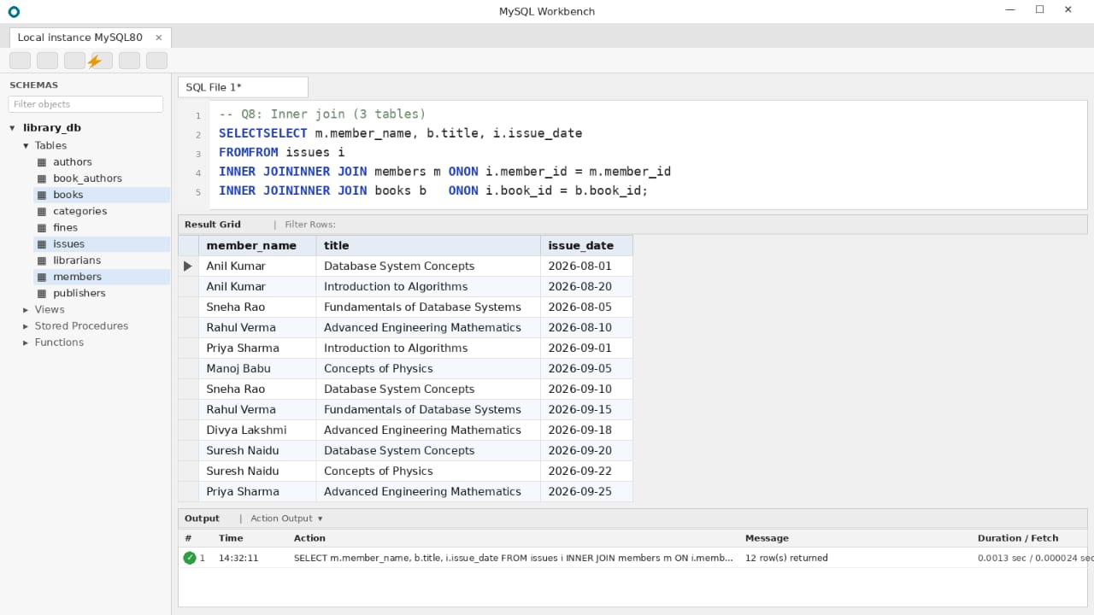

Fig. 7.1: Issue History of Members – Inner Join (Q8)
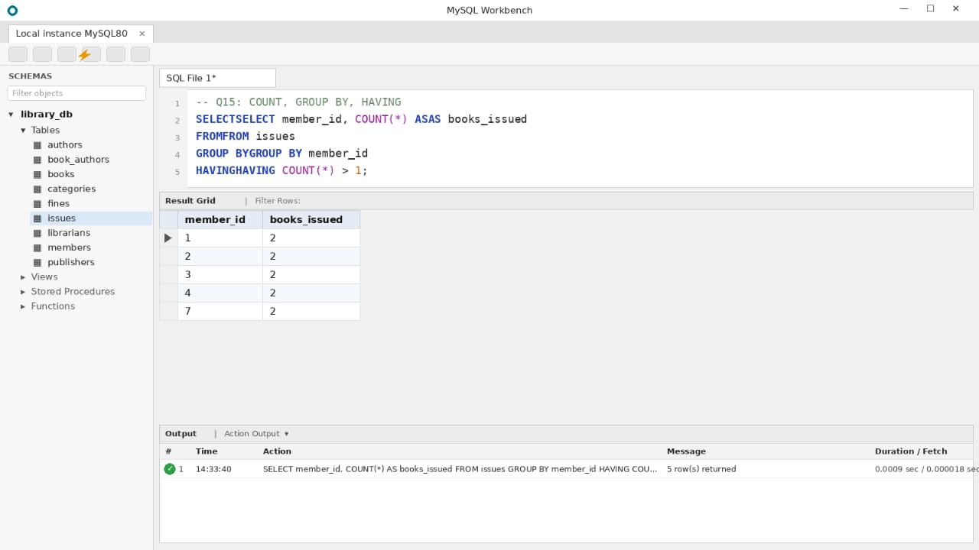

Fig. 7.2: Members with More Than One Issue – GROUP BY and HAVING (Q15)
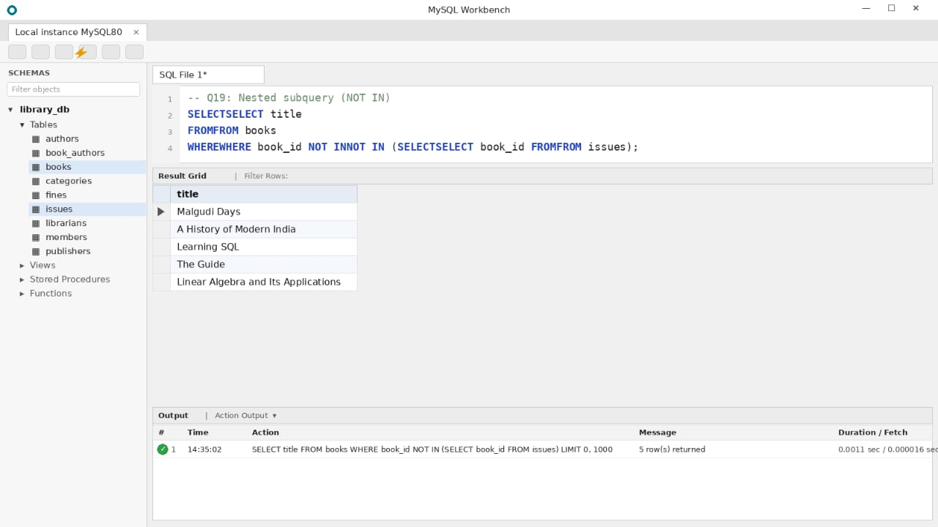

Fig. 7.3: Books Never Issued – Nested Subquery (Q19)
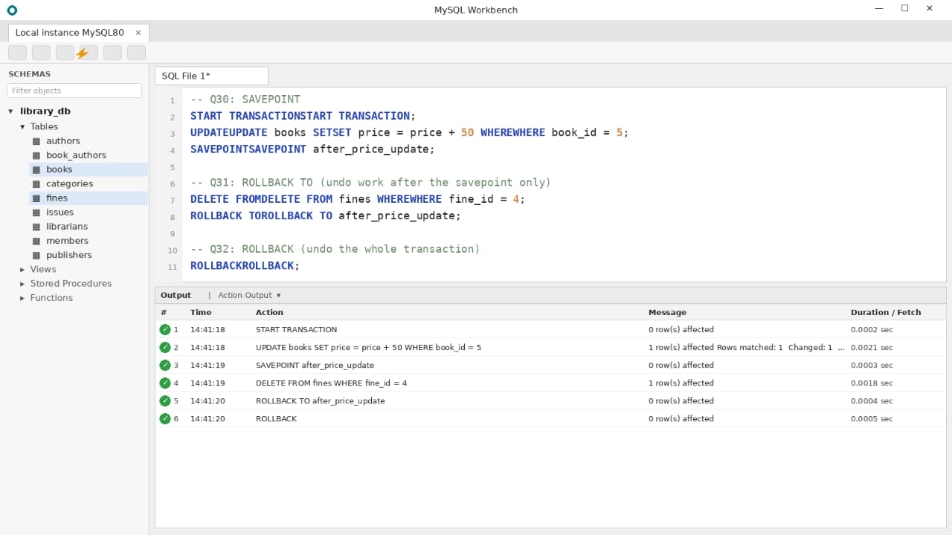

Fig. 7.4: Transaction Control – SAVEPOINT and ROLLBACK (Q30 to Q32)

CHAPTER 8: TESTING AND DATA VALIDATION
The test cases in Table 8.1 verify the constraints, the referential integrity and the correctness of the queries.
Table 8.1: Test Cases and Results
TC No. | Test Case Description | Input / Action | Expected Result | Actual Result | Status
TC1 | Primary key uniqueness | INSERT a member with an existing member_id (1) | Rejected: ERROR 1062 Duplicate entry | Error 1062: Duplicate entry | Pass
TC2 | NOT NULL | INSERT a book with title = NULL | Rejected: ERROR 1048 Column cannot be null | Error 1048: Column cannot be null | Pass
TC3 | UNIQUE | INSERT a book with an ISBN already present | Rejected: ERROR 1062 Duplicate entry | Error 1062: Duplicate entry | Pass
TC4 | CHECK (price) | INSERT a book with price = -100 | Rejected: ERROR 3819 Check constraint violated | Error 3819: Check constraint violated | Pass
TC5 | CHECK (dates) | INSERT an issue with due_date earlier than issue_date | Rejected: ERROR 3819 Check constraint violated | Error 3819: Check constraint violated | Pass
TC6 | Foreign key (insert) | INSERT an issue for member_id = 999 | Rejected: ERROR 1452 Cannot add or update a child row | Error 1452: Cannot add or update a child row | Pass
TC7 | Foreign key (delete) | DELETE FROM members WHERE member_id = 1 | Rejected: ERROR 1451 Cannot delete or update a parent row | Error 1451: Cannot delete or update a parent row | Pass
TC8 | Query correctness | Run Q15 (members with more than one issue) | Returns only members 1, 2, 3, 4 and 7 with count 2 | Members 1, 2, 3, 4 and 7 returned, count 2 | Pass
TC9 | Transaction rollback | Run Q30 to Q32 and then SELECT price FROM books WHERE book_id = 5 | Price returns to 250.00 after ROLLBACK | Price returned to 250.00 | Pass

CHAPTER 9: GITHUB REPOSITORY AND TEAM CONTRIBUTION

9.1 Repository Details
GitHub Repository Link: ______________________________________________________
The final SQL script and all project files must be pushed to the team repository.

9.2 Team Responsibilities and Contribution
Table 9.1: Team Responsibilities
S.No | Student Name | Roll Number | Role / Responsibility | Modules Contributed
1 | P. Venkat | 25B11AI951 | Database design: entities, ER diagram, relational schema, normalization | Book Catalogue, Fine Management
2 | P. Kiran | 25B11AI977 | Implementation: DDL, sample data, constraints and data validation | Member Management, Circulation
3 | K. Karunya | 25B11AI748 | SQL queries, testing, GitHub repository and documentation | Reports and Views, Staff Management

9.3 Review-wise Progress
Table 9.2: Review-wise Progress Record
Review | Date | Deliverables Presented | Remarks of the Guide
Review – I |  | Entities, attributes, ER diagram, relational schema, keys and normalization up to 3NF
Review – II |  | DDL, sample data insertion, constraints and data validation
Final Review |  | Complete SQL queries, testing, GitHub repository and project report

CHAPTER 10: CONCLUSION AND FUTURE ENHANCEMENTS

10.1 Conclusion
This project designed and implemented a Library Management System database in MySQL. Eight entities (Publisher, Category, Author, Book, Member, Librarian, Issue and Fine) were identified and converted into nine tables, including the Book_Authors table that resolves the many-to-many relationship between books and authors. The design was normalized from an unnormalized relation to Third Normal Form, and keys and constraints were applied to keep the data consistent.
Thirty-two SQL statements covering DDL, DML, retrieval, joins, aggregates, subqueries, views, set operations, DCL and TCL were written, and test cases were prepared for constraints and referential integrity. Each objective in Section 1.4 was therefore met: a normalized design, a constrained implementation, circulation and fine tracking, a broad set of queries, and testing with the script shared on GitHub.

10.2 Limitations of the Present Work
The present database does not support reservation of books, online payment of fines, e-books, barcode scanning or a graphical user interface. Fines are stored as amounts entered by the librarian and are not yet calculated automatically, and available_copies must be updated by the librarian when books are issued and returned.

10.3 Future Enhancements
Future work includes a front-end application for librarians and members, triggers that update available_copies and calculate fines automatically on issue and return, stored procedures for issuing and returning books, indexes on frequently searched columns such as title and isbn, role-based security, scheduled backup and recovery, and reports and analytics on popular books and overdue trends.

REFERENCES
- Abraham Silberschatz, Henry F. Korth and S. Sudarshan, “Database System Concepts”, 8th Edition, McGraw-Hill, ISBN: 978-1260230508.
- Raghurama Krishnan and Johannes Gehrke, “Database Management Systems”, 4th Edition, McGraw-Hill, ISBN: 978-1260091195.
- Ramez Elmasri and Shamkant B. Navathe, “Fundamentals of Database Systems”, 7th Edition, Pearson, ISBN: 978-0137504277.
- MySQL 8.0 Reference Manual, Oracle Corporation, https://dev.mysql.com/doc/refman/8.0/en/
- Graphviz Documentation, https://graphviz.org/documentation/

APPENDIX A – COMPLETE SQL SCRIPT
The complete script (DDL, sample data and queries Q1 to Q32) is given below and is also available in the GitHub repository.
-- ===== PART 1: DDL =====
CREATE DATABASE IF NOT EXISTS library_db;
USE library_db;

CREATE TABLE publishers (
publisher_id INT AUTO_INCREMENT PRIMARY KEY,
publisher_name VARCHAR(100) NOT NULL,
city VARCHAR(50)
);

CREATE TABLE categories (
category_id INT AUTO_INCREMENT PRIMARY KEY,
category_name VARCHAR(50) NOT NULL UNIQUE
);

CREATE TABLE authors (
author_id INT AUTO_INCREMENT PRIMARY KEY,
author_name VARCHAR(100) NOT NULL
);

CREATE TABLE books (
book_id INT AUTO_INCREMENT PRIMARY KEY,
title VARCHAR(150) NOT NULL,
isbn VARCHAR(20) NOT NULL UNIQUE,
price DECIMAL(8,2) NOT NULL,
total_copies INT NOT NULL DEFAULT 1,
available_copies INT NOT NULL DEFAULT 1,
publisher_id INT NOT NULL,
category_id INT NOT NULL,
CONSTRAINT chk_books_price CHECK (price > 0),
CONSTRAINT chk_books_copies CHECK (total_copies >= 0
AND available_copies >= 0 AND available_copies <= total_copies),
CONSTRAINT fk_books_publisher FOREIGN KEY (publisher_id)
REFERENCES publishers(publisher_id),
CONSTRAINT fk_books_category FOREIGN KEY (category_id)
REFERENCES categories(category_id)
);

CREATE TABLE book_authors (
book_id INT NOT NULL,
author_id INT NOT NULL,
PRIMARY KEY (book_id, author_id),
CONSTRAINT fk_ba_book FOREIGN KEY (book_id)
REFERENCES books(book_id) ON DELETE CASCADE,
CONSTRAINT fk_ba_author FOREIGN KEY (author_id)
REFERENCES authors(author_id)
);

CREATE TABLE members (
member_id INT AUTO_INCREMENT PRIMARY KEY,
member_name VARCHAR(100) NOT NULL,
email VARCHAR(100) NOT NULL UNIQUE,
phone VARCHAR(15),
join_date DATE NOT NULL,
status VARCHAR(10) NOT NULL DEFAULT 'Active',
CONSTRAINT chk_members_status CHECK (status IN ('Active','Inactive'))
);

CREATE TABLE librarians (
librarian_id INT AUTO_INCREMENT PRIMARY KEY,
librarian_name VARCHAR(100) NOT NULL,
shift VARCHAR(10) NOT NULL,
CONSTRAINT chk_librarians_shift CHECK (shift IN ('Morning','Evening'))
);

CREATE TABLE issues (
issue_id INT AUTO_INCREMENT PRIMARY KEY,
member_id INT NOT NULL,
book_id INT NOT NULL,
librarian_id INT NOT NULL,
issue_date DATE NOT NULL,
due_date DATE NOT NULL,
return_date DATE NULL,
CONSTRAINT chk_issues_dates CHECK (due_date > issue_date),
CONSTRAINT fk_issues_member FOREIGN KEY (member_id)
REFERENCES members(member_id),
CONSTRAINT fk_issues_book FOREIGN KEY (book_id)
REFERENCES books(book_id),
CONSTRAINT fk_issues_librarian FOREIGN KEY (librarian_id)
REFERENCES librarians(librarian_id)
);

CREATE TABLE fines (
fine_id INT AUTO_INCREMENT PRIMARY KEY,
issue_id INT NOT NULL UNIQUE,
fine_amount DECIMAL(8,2) NOT NULL,
paid_status VARCHAR(10) NOT NULL DEFAULT 'Unpaid',
CONSTRAINT chk_fines_amount CHECK (fine_amount >= 0),
CONSTRAINT chk_fines_status CHECK (paid_status IN ('Paid','Unpaid')),
CONSTRAINT fk_fines_issue FOREIGN KEY (issue_id)
REFERENCES issues(issue_id)
);

ALTER TABLE members
ADD CONSTRAINT chk_members_phone CHECK (CHAR_LENGTH(phone) = 10);

-- ===== PART 2: DML (sample data) =====
INSERT INTO publishers (publisher_name, city) VALUES
('McGraw-Hill Education','New York'),
('Pearson','London'),
('Oxford University Press','Oxford'),
('O''Reilly Media','Sebastopol'),
('Wiley India','New Delhi');

INSERT INTO categories (category_name) VALUES
('Computer Science'),('Mathematics'),('Literature'),('Physics'),('History');

INSERT INTO authors (author_name) VALUES
('Abraham Silberschatz'),('Henry F. Korth'),('S. Sudarshan'),
('Ramez Elmasri'),('Shamkant B. Navathe'),('Thomas H. Cormen'),
('R. K. Narayan'),('Erwin Kreyszig'),('H. C. Verma'),
('Bipin Chandra'),('Alan Beaulieu'),('Gilbert Strang');

INSERT INTO books (title, isbn, price, total_copies, available_copies,
publisher_id, category_id) VALUES
('Database System Concepts','978-1-0000-0001-1',899.00,5,3,1,1),
('Fundamentals of Database Systems','978-1-0000-0002-2',849.00,4,3,2,1),
('Introduction to Algorithms','978-1-0000-0003-3',1199.00,3,1,1,1),
('Advanced Engineering Mathematics','978-1-0000-0004-4',699.00,6,6,5,2),
('Malgudi Days','978-1-0000-0005-5',250.00,4,4,3,3),
('Concepts of Physics','978-1-0000-0006-6',550.00,3,2,5,4),
('A History of Modern India','978-1-0000-0007-7',420.00,2,2,3,5),
('Learning SQL','978-1-0000-0008-8',650.00,3,3,4,1),
('The Guide','978-1-0000-0009-9',300.00,3,3,3,3),
('Linear Algebra and Its Applications','978-1-0000-0010-0',480.00,2,2,2,2);

INSERT INTO book_authors (book_id, author_id) VALUES
(1,1),(1,2),(1,3),(2,4),(2,5),(3,6),(4,8),
(5,7),(6,9),(7,10),(8,11),(9,7),(10,12);

INSERT INTO members (member_name, email, phone, join_date) VALUES
('Anil Kumar','anil.kumar@example.com','9876543210','2026-01-10'),
('Sneha Rao','sneha.rao@example.com','9876543211','2026-01-15'),
('Rahul Verma','rahul.v@example.com','9876543212','2026-02-03'),
('Priya Sharma','priya.s@example.com','9876543213','2026-02-20'),
('Manoj Babu','manoj.b@example.com','9876543214','2025-11-05'),
('Divya Lakshmi','divya.l@example.com','9876543215','2026-03-12'),
('Suresh Naidu','suresh.n@example.com','9876543216','2025-12-18'),
('Harika Devi','harika.d@example.com','9876543217','2026-04-01');

INSERT INTO librarians (librarian_name, shift) VALUES
('Ravi Teja','Morning'),('Lakshmi Prasanna','Evening'),('Srinivas Rao','Morning');

INSERT INTO issues (member_id, book_id, librarian_id,
issue_date, due_date, return_date) VALUES
(1,1,1,'2026-08-01','2026-08-15','2026-08-14'),
(1,3,1,'2026-08-20','2026-09-03',NULL),
(2,2,2,'2026-08-05','2026-08-19','2026-08-25'),
(3,4,1,'2026-08-10','2026-08-24','2026-08-23'),
(4,3,3,'2026-09-01','2026-09-15',NULL),
(5,6,2,'2026-09-05','2026-09-19','2026-09-30'),
(2,1,2,'2026-09-10','2026-09-24',NULL),
(3,2,3,'2026-09-15','2026-09-29',NULL),
(6,4,1,'2026-09-18','2026-10-02','2026-10-01'),
(7,1,3,'2026-09-20','2026-10-04',NULL),
(7,6,1,'2026-09-22','2026-10-06',NULL),
(4,4,2,'2026-09-25','2026-10-09','2026-09-30');

INSERT INTO fines (issue_id, fine_amount, paid_status) VALUES
(3,12.00,'Paid'),(6,22.00,'Unpaid'),(2,62.00,'Unpaid'),(5,38.00,'Unpaid');

-- UPDATE and DELETE examples
UPDATE members SET phone = '9876500000' WHERE member_id = 2;
UPDATE books SET price = 920.00 WHERE book_id = 1;
INSERT INTO members (member_name, email, phone, join_date)
VALUES ('Test User','test.user@example.com','9000000000','2026-10-01');
DELETE FROM members WHERE email = 'test.user@example.com';

-- ===== PART 3: QUERIES Q1-Q32 =====
-- 5.1 Basic retrieval
-- Q1: Display all books in the catalogue
SELECT * FROM books;
-- Q2: Books priced above Rs. 500, costliest first
SELECT title, price FROM books
WHERE price > 500 ORDER BY price DESC;
-- Q3: Members who joined in 2026
SELECT member_name, email FROM members
WHERE join_date >= '2026-01-01';
-- Q4: Books whose title contains 'Database'
SELECT book_id, title FROM books
WHERE title LIKE '%Database%';
-- Q5: Books issued but not yet returned
SELECT issue_id, member_id, book_id, due_date
FROM issues WHERE return_date IS NULL;

-- 5.2 Joins
-- Q6: Natural join
SELECT title, category_name
FROM books NATURAL JOIN categories;
-- Q7: Equi join
SELECT b.title, p.publisher_name
FROM books b, publishers p
WHERE b.publisher_id = p.publisher_id;
-- Q8: Inner join (3 tables)
SELECT m.member_name, b.title, i.issue_date
FROM issues i
INNER JOIN members m ON i.member_id = m.member_id
INNER JOIN books b ON i.book_id = b.book_id;
-- Q9: Left outer join
SELECT m.member_name, i.issue_id
FROM members m
LEFT JOIN issues i ON m.member_id = i.member_id;
-- Q10: Right outer join
SELECT i.issue_id, b.title
FROM issues i
RIGHT JOIN books b ON i.book_id = b.book_id;
-- Q11: Full outer join (LEFT UNION RIGHT)
SELECT b.title, i.issue_id
FROM books b LEFT JOIN issues i ON b.book_id = i.book_id
UNION
SELECT b.title, i.issue_id
FROM books b RIGHT JOIN issues i ON b.book_id = i.book_id;

-- 5.3 Aggregates
-- Q12: COUNT
SELECT COUNT(*) AS total_titles FROM books;
-- Q13: SUM, AVG
SELECT SUM(total_copies) AS copies, AVG(price) AS avg_price
FROM books;
-- Q14: COUNT with GROUP BY
SELECT c.category_name, COUNT(*) AS titles
FROM books b JOIN categories c
ON b.category_id = c.category_id
GROUP BY c.category_name;
-- Q15: COUNT, GROUP BY, HAVING
SELECT member_id, COUNT(*) AS books_issued
FROM issues GROUP BY member_id
HAVING COUNT(*) > 1;
-- Q16: MAX, MIN
SELECT MAX(price) AS costliest, MIN(price) AS cheapest
FROM books;

-- 5.4 Subqueries
-- Q17: Nested (scalar subquery)
SELECT title, price FROM books
WHERE price > (SELECT AVG(price) FROM books);
-- Q18: Nested (IN)
SELECT member_name FROM members
WHERE member_id IN (SELECT member_id FROM issues);
-- Q19: Nested (NOT IN)
SELECT title FROM books
WHERE book_id NOT IN (SELECT book_id FROM issues);
-- Q20: Correlated
SELECT b.title, b.price FROM books b
WHERE b.price > (SELECT AVG(b2.price) FROM books b2
WHERE b2.category_id = b.category_id);
-- Q21: Correlated (EXISTS)
SELECT m.member_name FROM members m
WHERE EXISTS (SELECT 1 FROM issues i
JOIN fines f ON f.issue_id = i.issue_id
WHERE i.member_id = m.member_id
AND f.paid_status = 'Unpaid');

-- 5.5 Views and set operations
-- Q22: Updatable view (simple, single table)
CREATE VIEW available_books AS
SELECT book_id, title, available_copies
FROM books WHERE available_copies > 0;
-- Q23: Non-updatable view (GROUP BY)
CREATE VIEW member_issue_count AS
SELECT m.member_id, m.member_name,
COUNT(i.issue_id) AS total_issues
FROM members m LEFT JOIN issues i
ON m.member_id = i.member_id
GROUP BY m.member_id, m.member_name;
-- Q24: UNION
SELECT member_name AS person_name FROM members
UNION
SELECT librarian_name FROM librarians;
-- Q25: INTERSECT
SELECT issue_id FROM issues
INTERSECT
SELECT issue_id FROM fines;
-- Q26: EXCEPT (MINUS)
SELECT book_id FROM books
EXCEPT
SELECT book_id FROM issues;

-- 5.6 DCL and TCL
-- Q27: GRANT - Give a staff user limited access
CREATE USER 'lib_staff'@'localhost'
IDENTIFIED BY 'Staff@2026';
GRANT SELECT, INSERT, UPDATE
ON library_db.issues TO 'lib_staff'@'localhost';
-- Q28: REVOKE - Withdraw the update privilege
REVOKE UPDATE ON library_db.issues
FROM 'lib_staff'@'localhost';
-- Q29: COMMIT - Make a change permanent
START TRANSACTION;
UPDATE members SET status = 'Inactive'
WHERE member_id = 8;
COMMIT;
-- Q30: SAVEPOINT - Mark a point inside a transaction
START TRANSACTION;
UPDATE books SET price = price + 50
WHERE book_id = 5;
SAVEPOINT after_price_update;
-- Q31: ROLLBACK TO - Undo work after the savepoint only
DELETE FROM fines WHERE fine_id = 4;
ROLLBACK TO after_price_update;
-- Q32: ROLLBACK - Undo the whole transaction
ROLLBACK;

